Name: | No.: | Class:
Date:
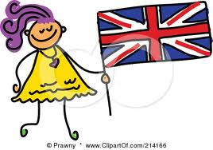
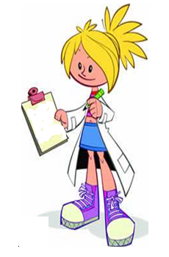
Read the letter Cindy is writing to her pen friend Robert.
Dear Robert,
My name is Cindy Johnson. I’m a student.
I’m 12 years old and I’m from Australia. I’m tall and thin. I’ve got long fair hair and big blue eyes. My nose is small but I’ve got a big mouth.
I’ve got a brother; his name’s Andrew. He is 17 years old. He is a handsome boy; he is tall and slim, his hair his dark and his eyes are green.
My parents are Charles and Ann. My father is a taxi driver and my mother is a nurse. They are both 39 years old. We are a happy family.
Write soon.
Love,
Cindy

I – Answer the questions.
- How old is Cindy?_____________________________________________________________________
- Is she Australian?_____________________________________________________________________
- Has she got two brothers?______________________________________________________________
- Who is Ann?_________________________________________________________________________
- Is Cindy fat? _________________________________________________________________________
- Has she got short hair? ________________________________________________________________
- What colour are her eyes? _____________________________________________________________
- What is Andrew like? _________________________________________________________________
_____________________________________________________________________________________
- How old are Charles and Ann?__________________________________________________________

II – This is Cindy’s pen friend, Robert. Read the answers and write the questions.

- _________________________________________________________?
Yes, he is tall.
- _________________________________________________________?
No, he hasn’t got curly hair.
- _________________________________________________________?
His eyes are blue.
- _________________________________________________________?
Robert is thirteen years old.
- _________________________________________________________?
He is from New York, in the USA.

