Name: | No.: | Class:
Date:
Hello! ___________ name is Jack and __________am eleven years old. _________ birthday is on 11th June. __________ parents are Susan and James. _______am English and _________ best friend is ___________ dog. | 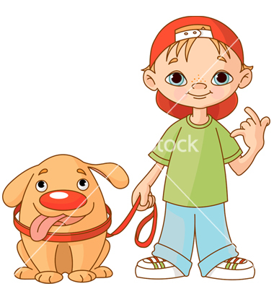  I / My
This is my father. __________name is James and _________ is from Scotland.  ________ is a teacher and _______ school is in London.  _______ birthday is in October. _________favourite sport is golf. |   He / His
This is my mother. __________ name is Susan and _______ is forty years old. _________ birthday is in February.  _________ is tall and slim. _________eyes are blue and _________has got brown hair. _________favourite hobby is reading. |   She / Her
This is my dog. _________ name is President. __________is five years old and __________ house is in the garden. | It / Its
This is my friend Sally. ___________are students and __________ are in the fourth grade. ____________school is in London and __________ favourite sport is tennis. __________are short and slim. _________eyes are green. |   We / Our
These are my grandparents. ________ are Mr and Mrs Silva. ________ house is in Madrid . ________ are Spanish.  __________ car is blue. | 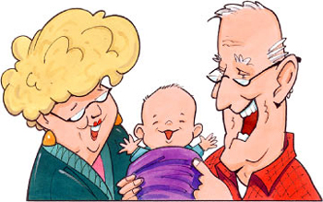  They / Their
What is __________ first name?  How old are _______? Where are ________ from?  When is ___________ birthday? | ?  You / Your

